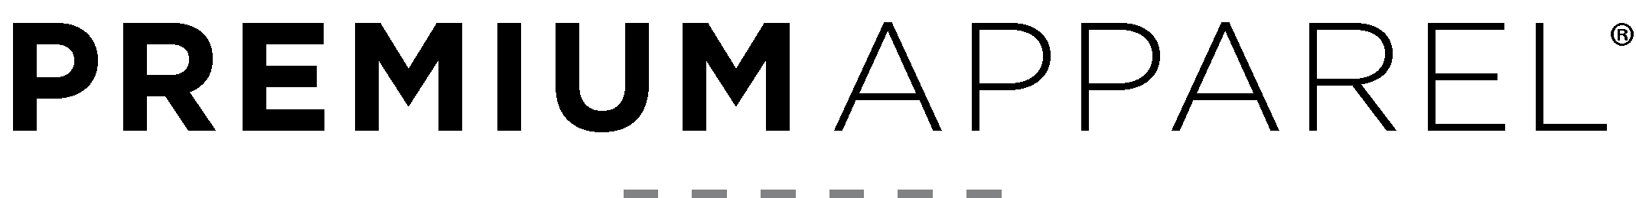

Online Product API

Authentication

Basic HTTP Authentication has been deprecated. If no authentication is provided, all data apart from prices will still be returned.

Bearer Token Authentication
If a valid bearer token is provided in the request header, client specific pricing will also be returned for the style specific endpoint.

Formats

All responses are in JSON format.
An error response will contain an error value such as:
{"error":true, "error_reason":"Bad request"}

Endpoints

Product details
https://hq.premiumapparel.co.nz/api/products
Returns all currently active online product details.

https://hq.premiumapparel.co.nz/api/products?style=18500BL
Returns details of one specific active online product specified by the style query parameter.

Stock levels
https://hq.premiumapparel.co.nz/api/stock?id=18500-BL-S
Returns the current stock level for one style/colour/size combination specified by the formatted id query parameter. ID is of the format <style>-<colour>-<size>.

Examples
Request
https://hq.premiumapparel.co.nz/api/products.php?style=18500
Recent additions/changes in blue.
Response (abbreviated)
{
"products": [
{
"brand": "Gildan",
"colours": [
{
"description ": "Black ",
"images": [
"https://..._18500BL_A1.jpg",
"https://...18500_18500BL_B1.jpg"
],
"name": "18500BL",
"sizes": [
{
"size": "S",
"sku": "18500BL-S",
"stock": 1082
},
{
"size": "M",
"sku": "18500BL-M",
"stock": 2094
},
...
]
},
...
],
"html_description": "<p><strong>Fit: </strong>...",
"price": 123.45,
"style": "18500",
"text_description": "Fit: Classic Fit\Fabric: 50% Cotton...",
"title": "18500 Gildan Heavy Blend Adult Hooded Sweatshirt"
}
]
}
Request
https://hq.premiumapparel.co.nz/api/stock?id=18500-18500BL-M

Response
{"size":"M","stock":2094}

